- Launch one EC2 instance using Amazon Linux 2.
Open AWS search for ec2 then goto dashboard click on create instance then give name to it then select os such as Amazon aws then select or create a .pem key then select a default security group and hit enter your ec2 instance is now created. Now start the instance and connect with local macine through ssh key.
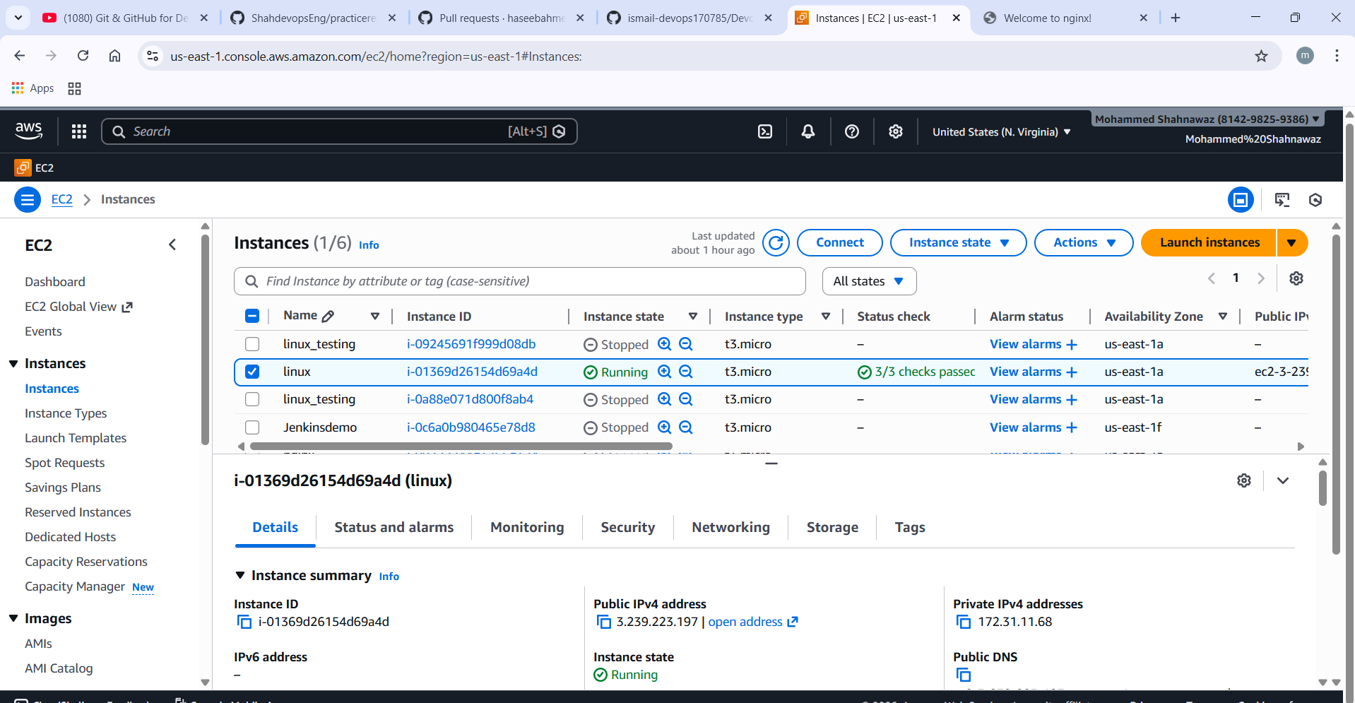

02) Install Nginx
Give command on gitbash terminal as yum install nginx then service will get installed.
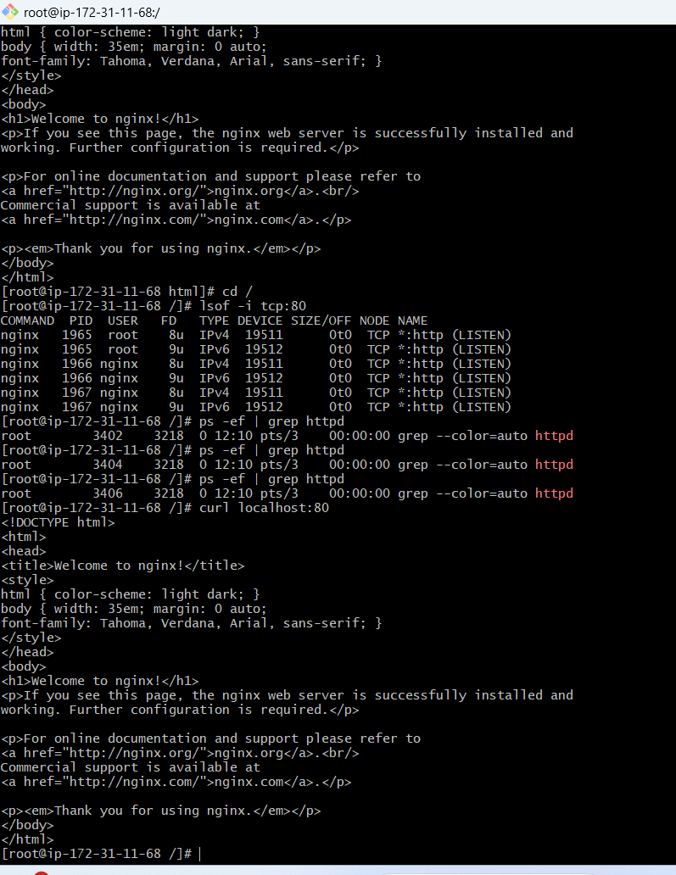

- Install Apache
Give command yum install httpd
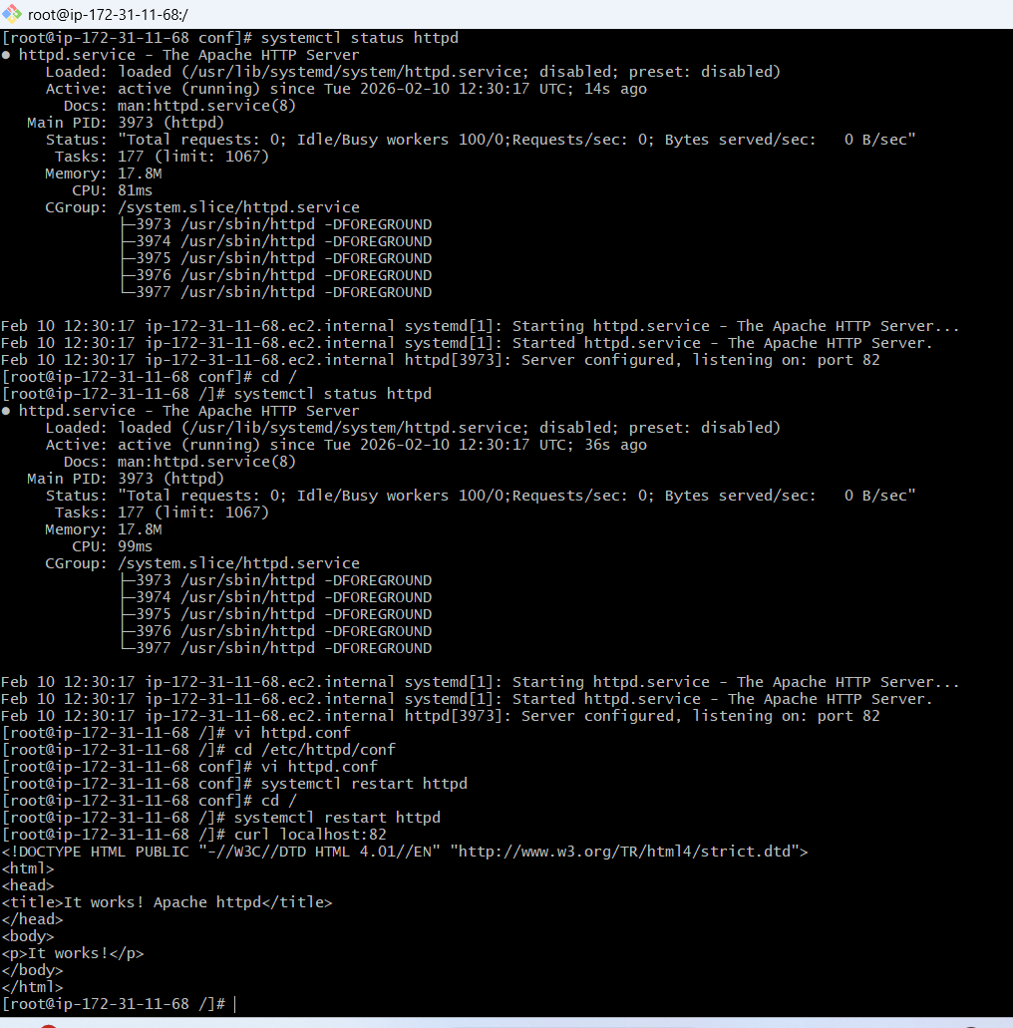

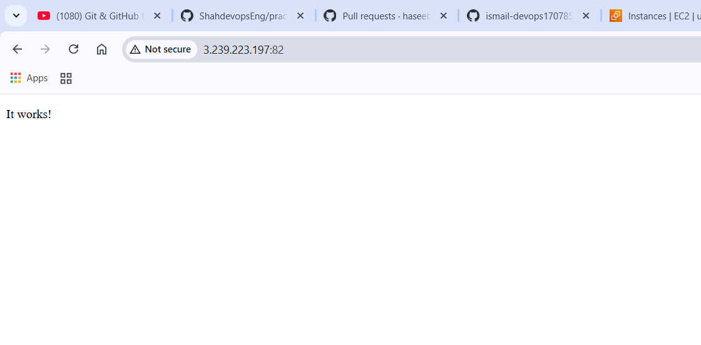

- Install Jenkins.
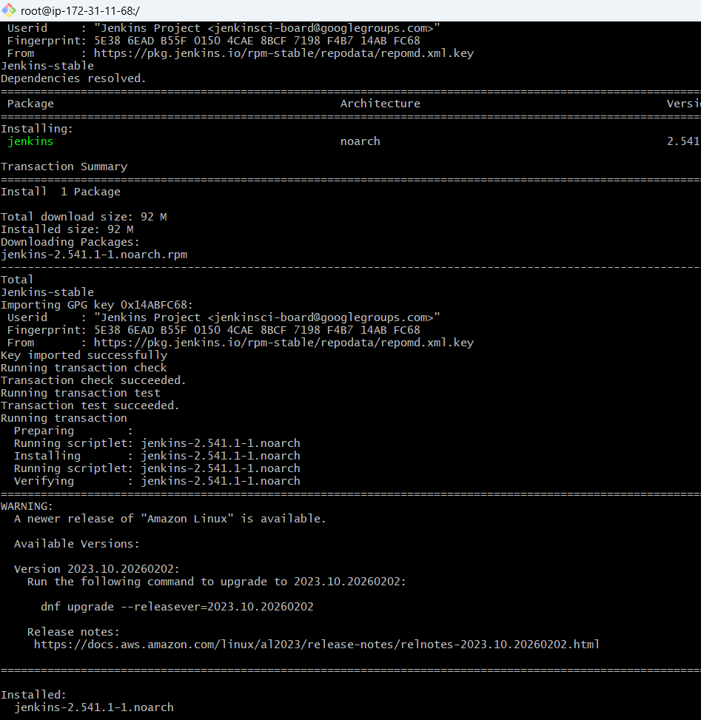

- Install Docker.
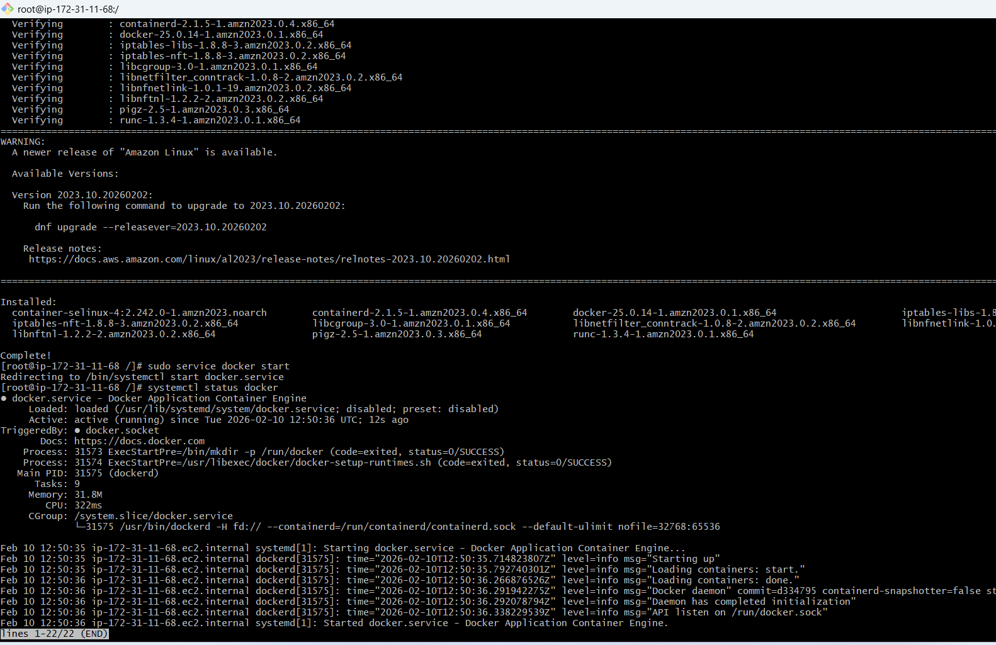

- Install Apache Tomcat
